Successfully Created Resource Group:

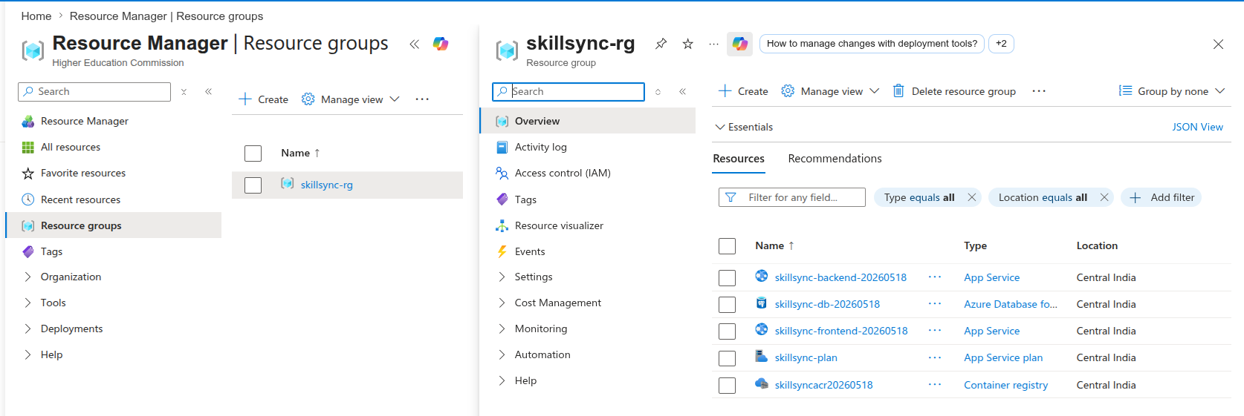

Successfully Created a PostgreSql Database:

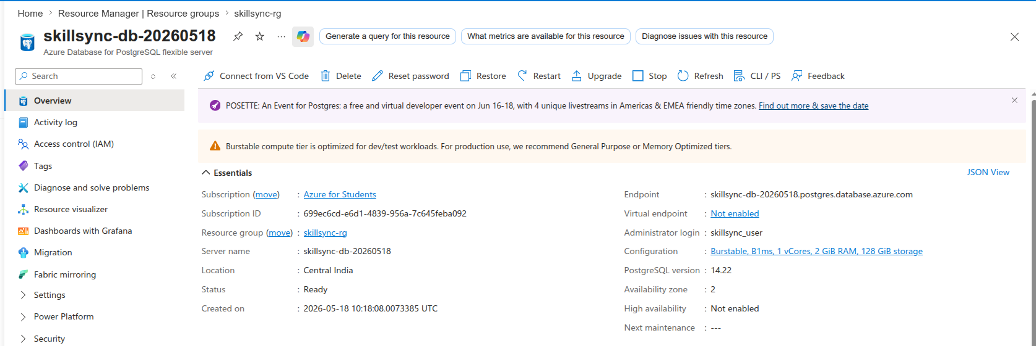
Successfull Deployment of Azure Container Registry:

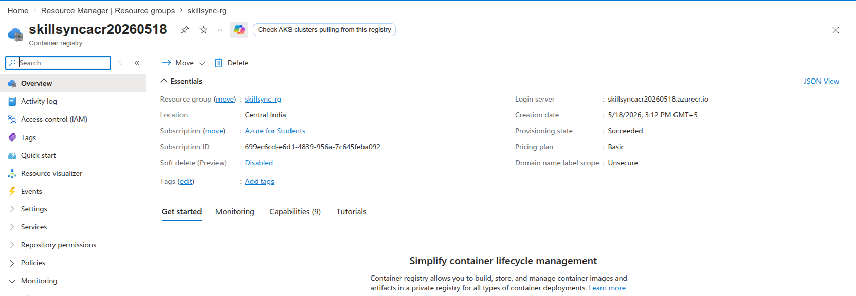

Successfully Deployed Backend:
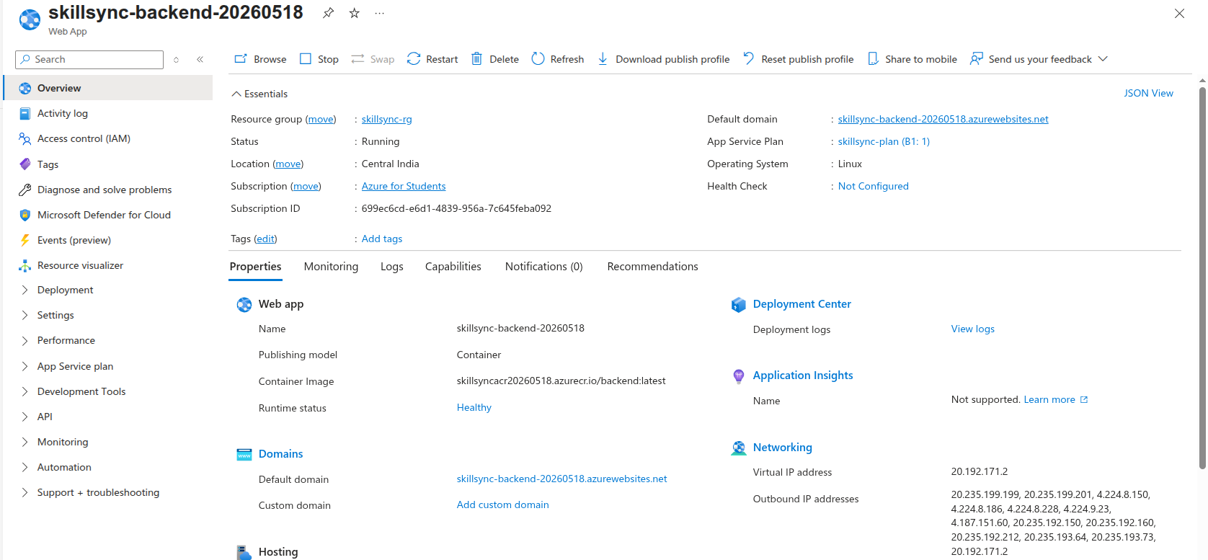
Back-end Deployment using ACR:
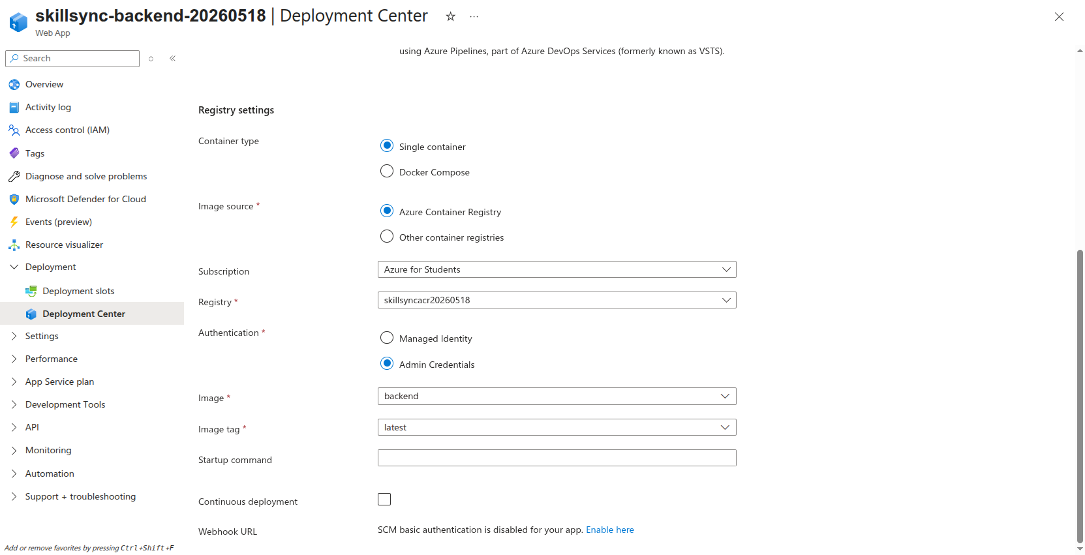

Successfull Deployment of Back-end:
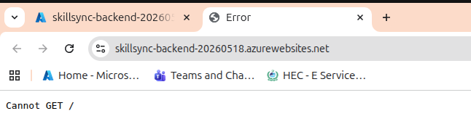

App Service Plan Successfully Created:
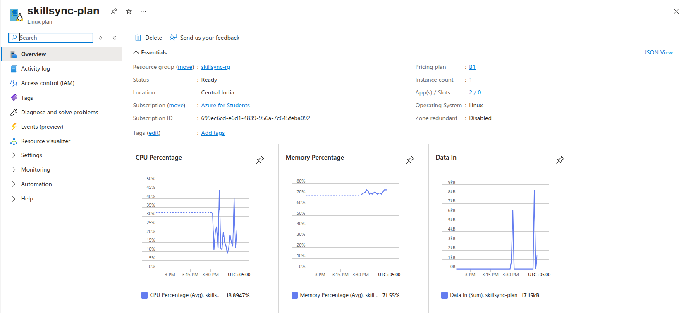

Successfully Deployed Front-End:
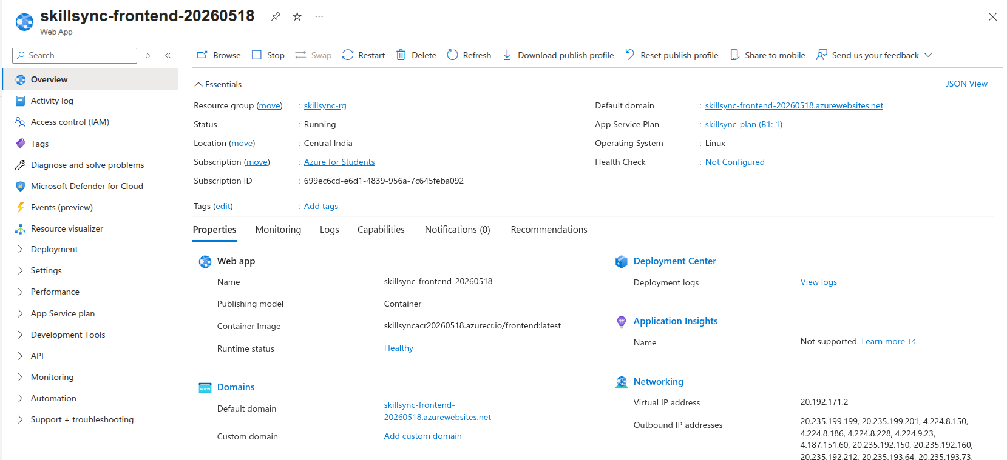

Front-End Deployment Proof:
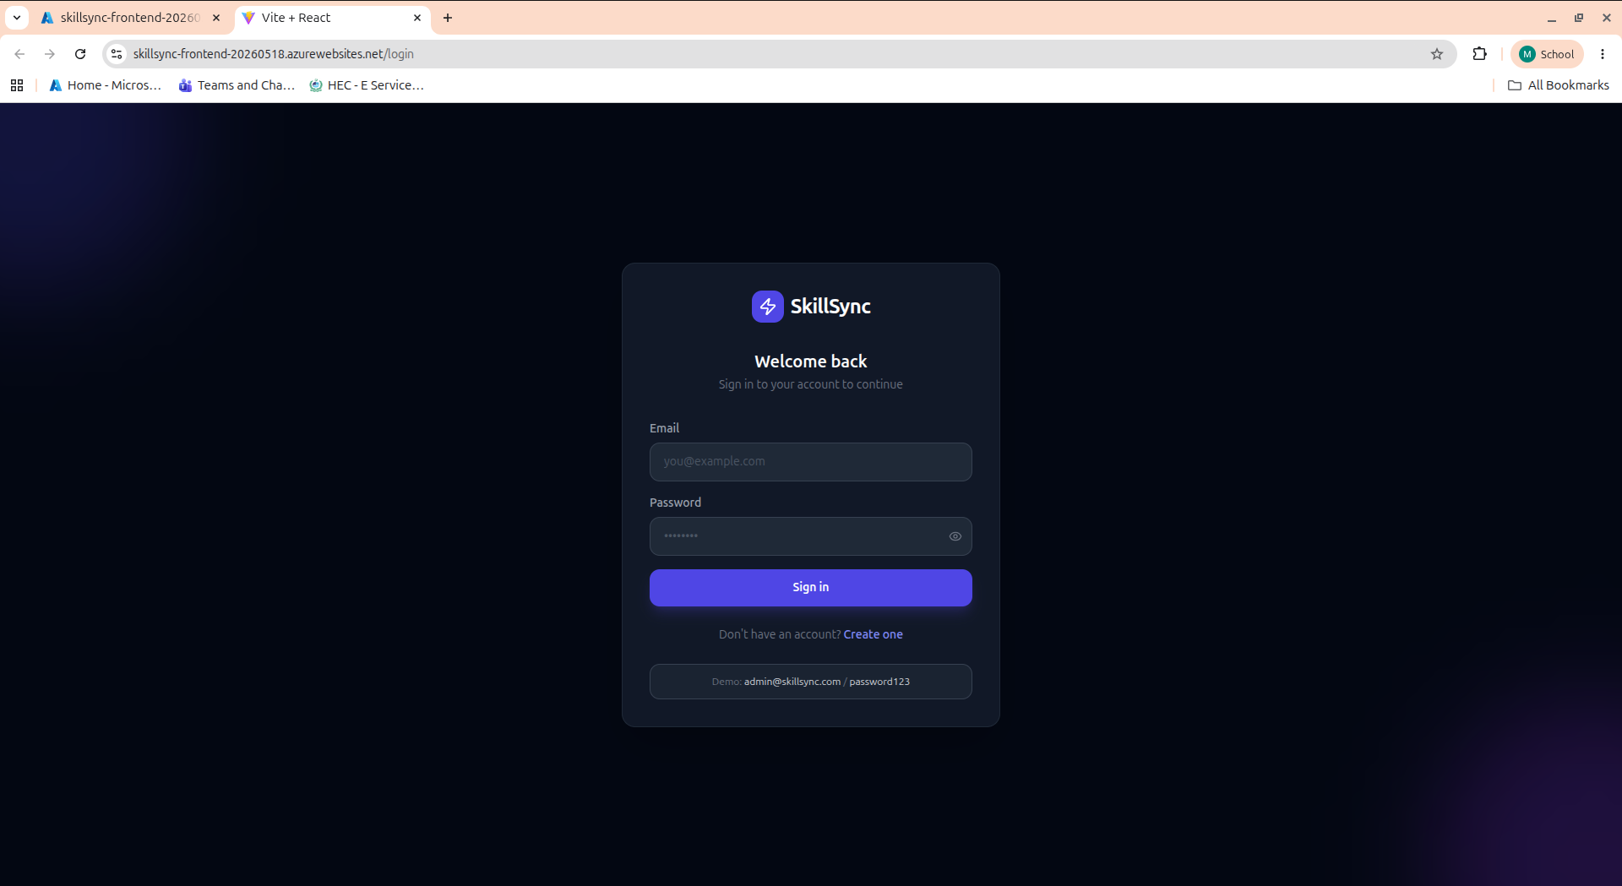
Live and fully-Integrated SkillSync Dashboard on Azure App Service:
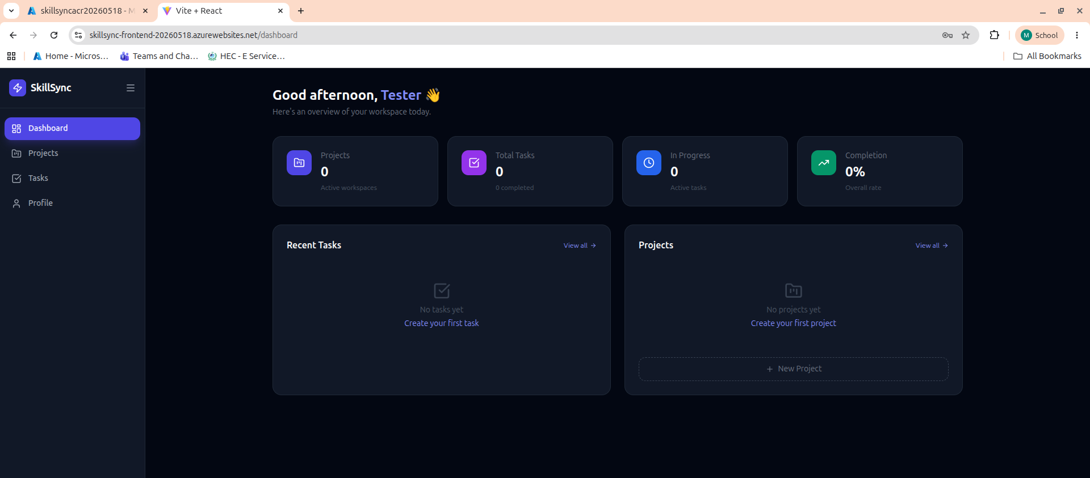

Created a New User and Signed in Successfully:
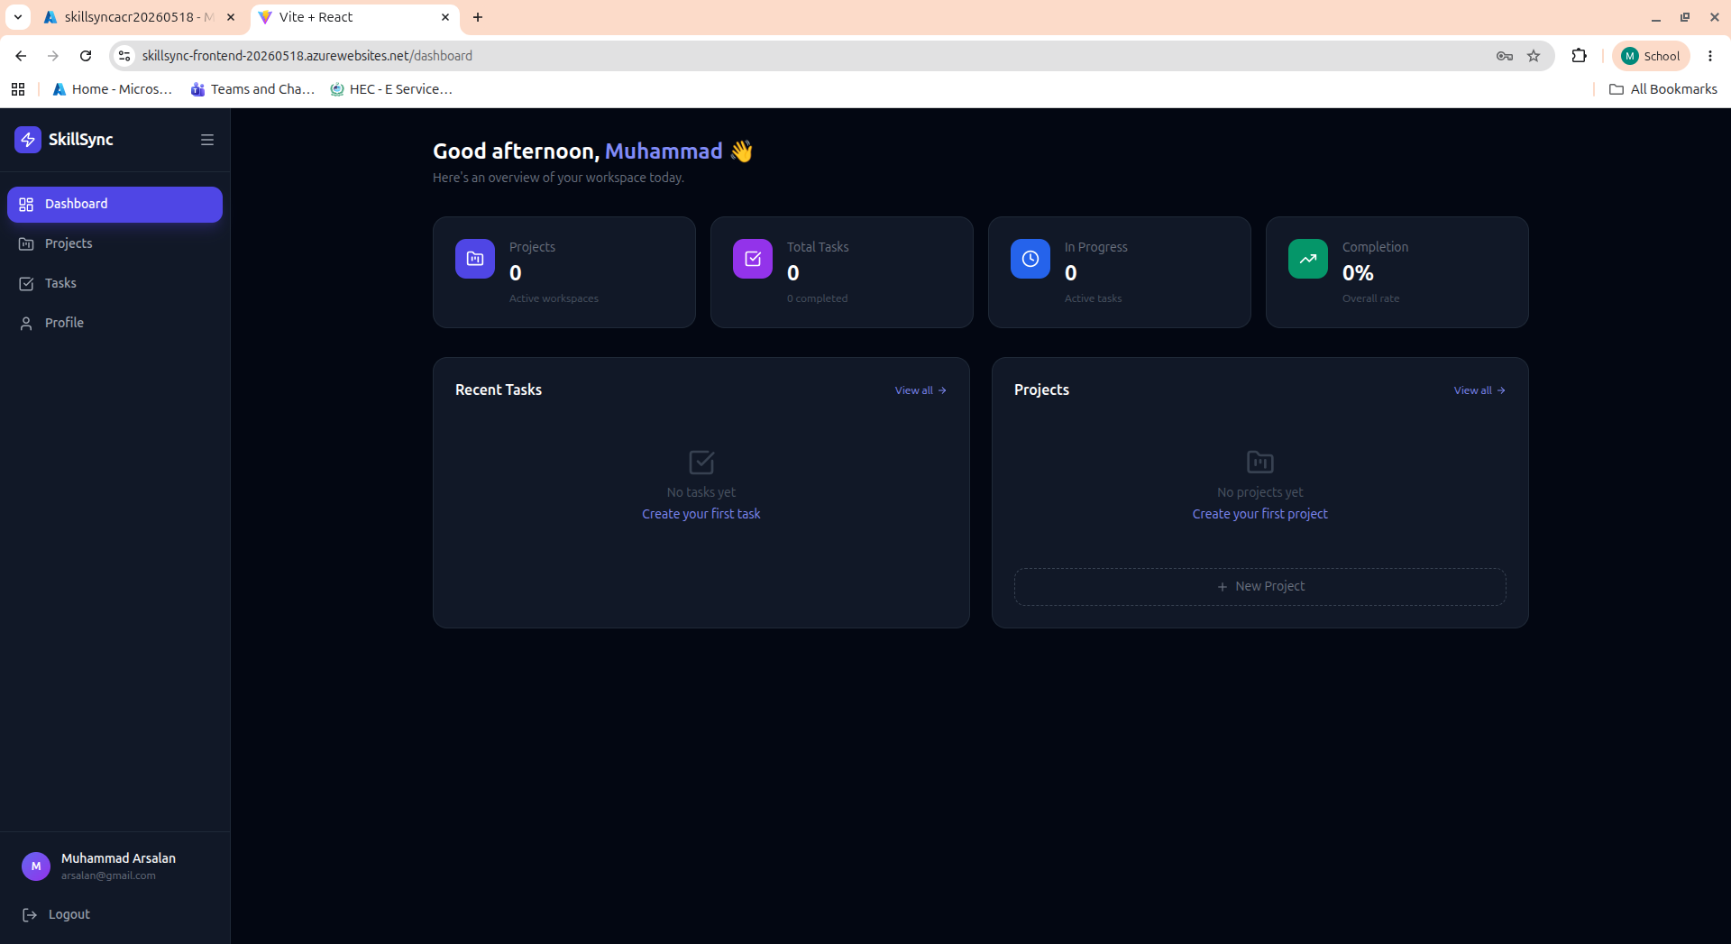
Grafana Monitoring:
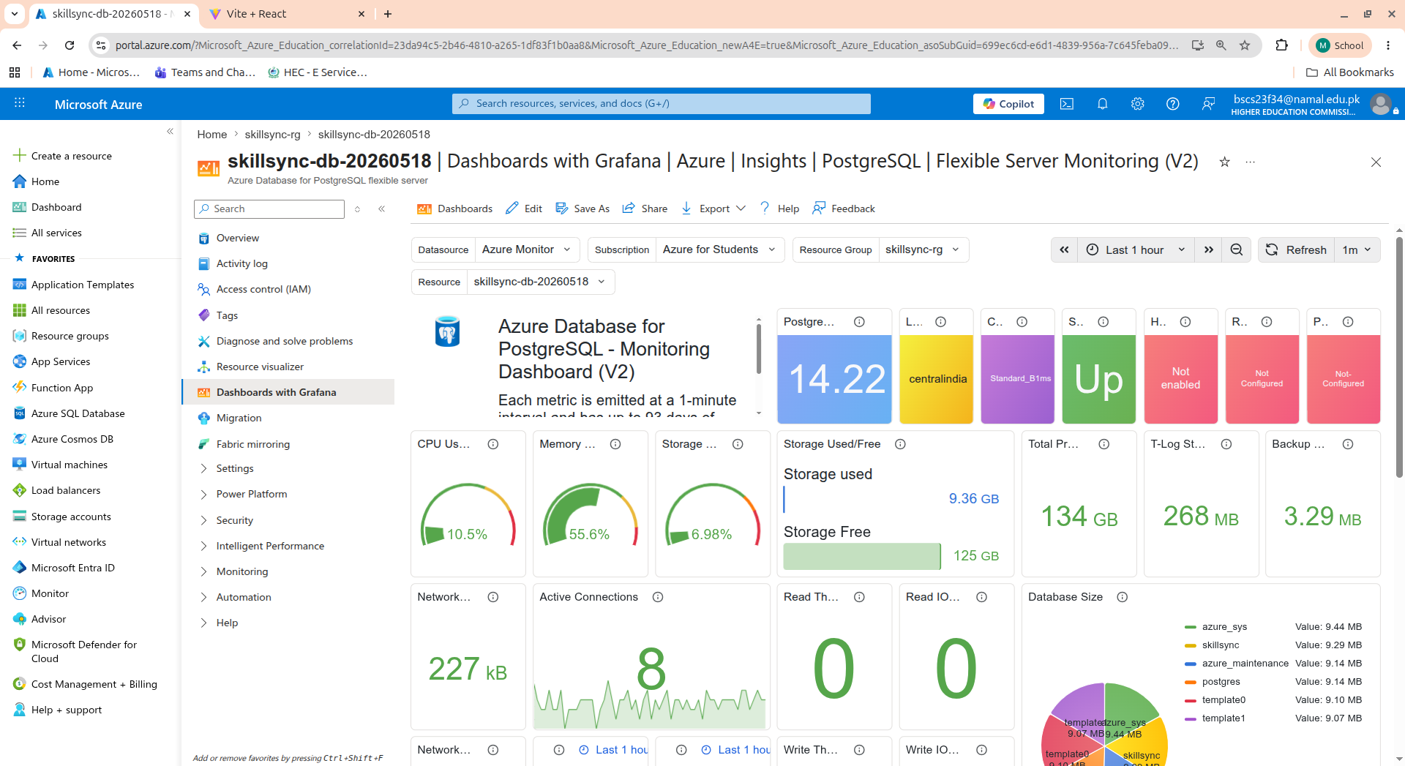

Successful Addition of a Project:
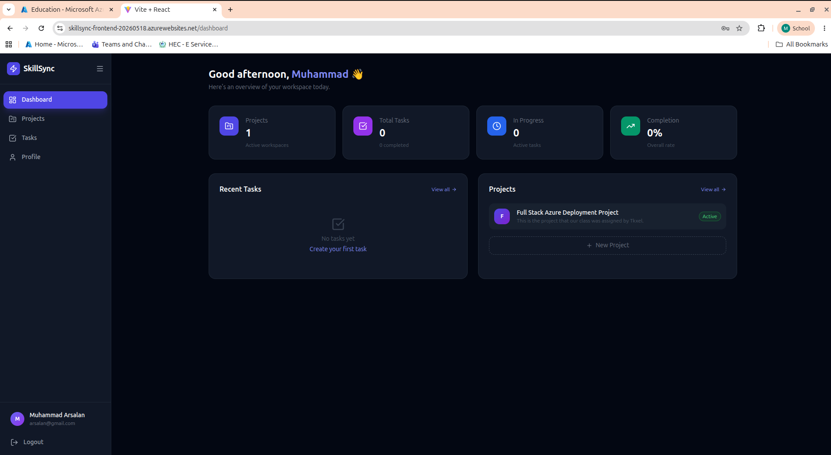
New Task Addition Screen:
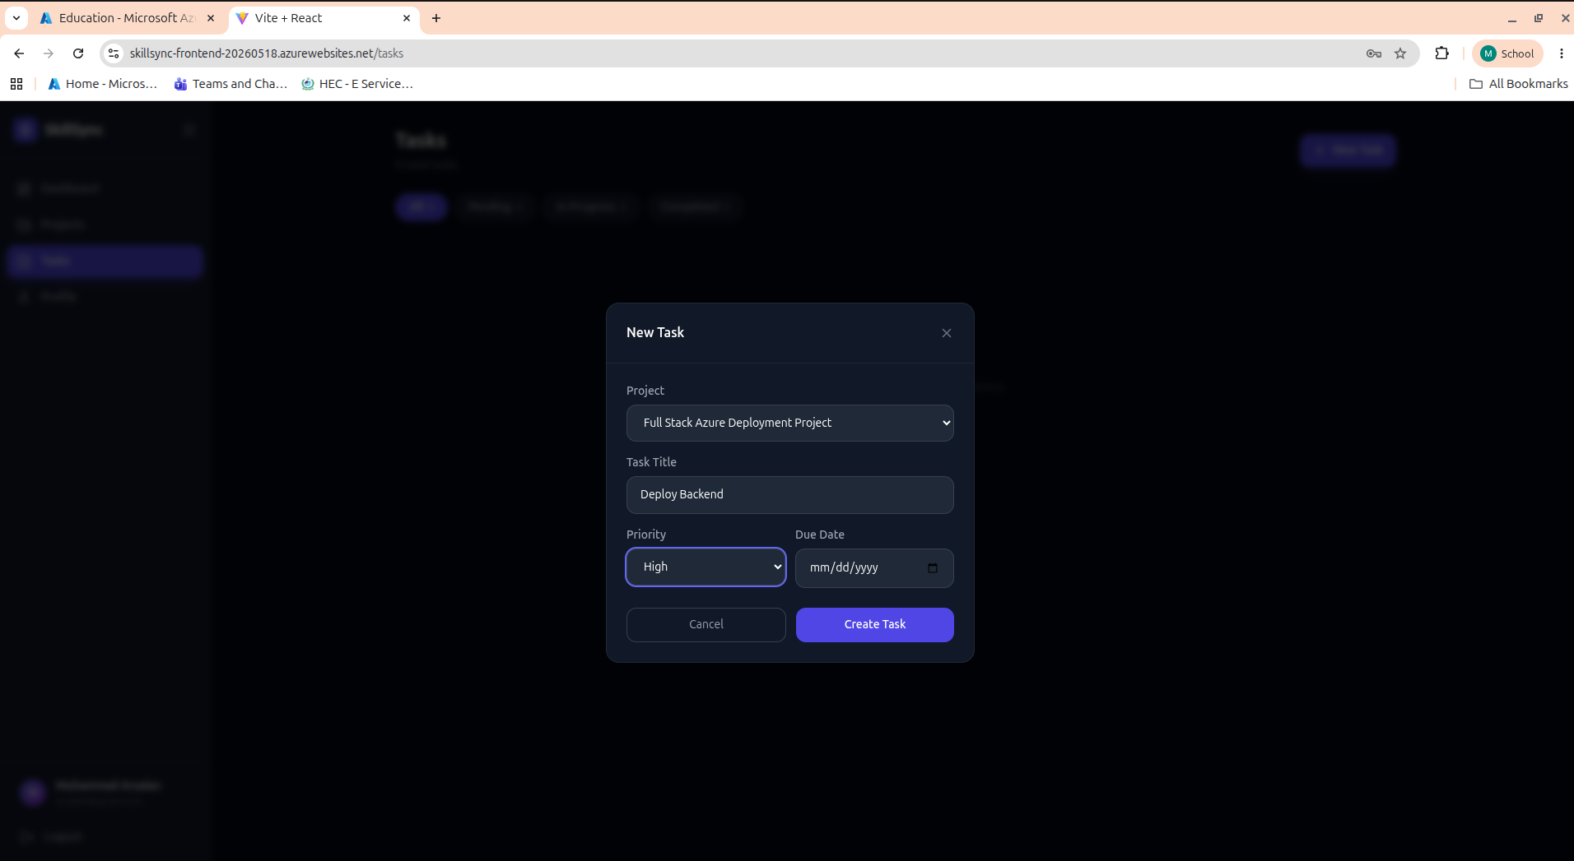

Completion of Task Screen:
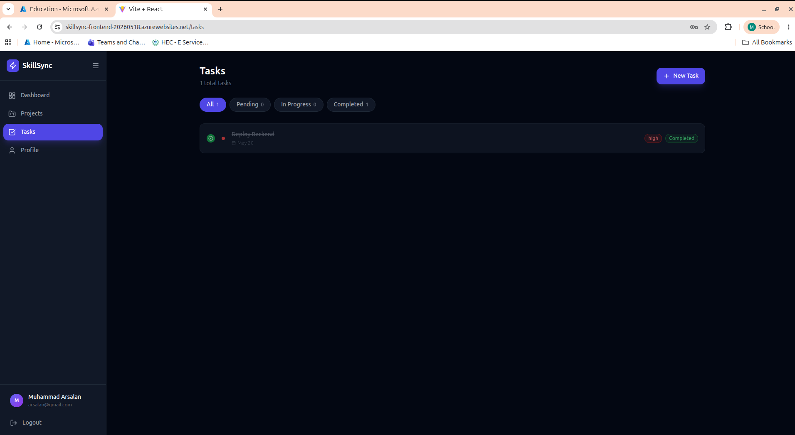
Complete Details About Tasks and Projects in Sync:
